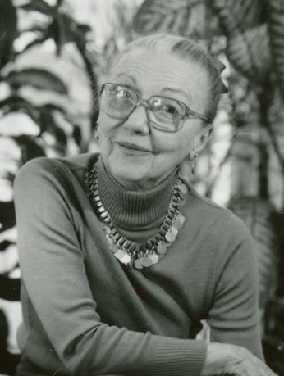
CONTRIBUTION TO

THE MARTHA HILL DANCE FUND

Gala Benefit, February 24, 2025

Manhattan Penthouse, NYC

Please reserve _________ ticket(s) as follows:

Platinum Table (for 10 guests) $5000 _____
Golden Table (for 10 guests) $3000 _____
Benefactor $2000 per person _____
Patron $800 per person _____
Sponsor $400 per person_____
Donor $200 per person ______

I/We will attend and would like to be seated (if possible) near ______________________________

I/We will contribute $125 to the attendance of a student.

I/We cannot attend, but will contribute $_________ to the Martha Hill Dance Fund.

Total Enclosed $____________ or pay online at: “marthahilldance.org”

***********************

I/We would like _____ Vegan Risotto, _____Chicken, ____Salmon Dinner(s).

MY NAME ____________________________________________________________

ADDRESS ___________________________________________________________

CITY ________________________ STATE _____ ZIP ______________________

TELEPHONE ______________________ EMAIL___________________________

NAME OF GUEST(S) and their email address(es) if applicable:

_______________________________________________________________________

And their meal preference ________________________________________________

Please make checks payable to Martha Hill Dance Fund and mail to:
MHDF, c/o Ernesta Corvino, 14 Little Fox Lane, Norwalk, CT 06850

RSVP by February 18th - There is an extra fee of $25 for late response

